Image 1
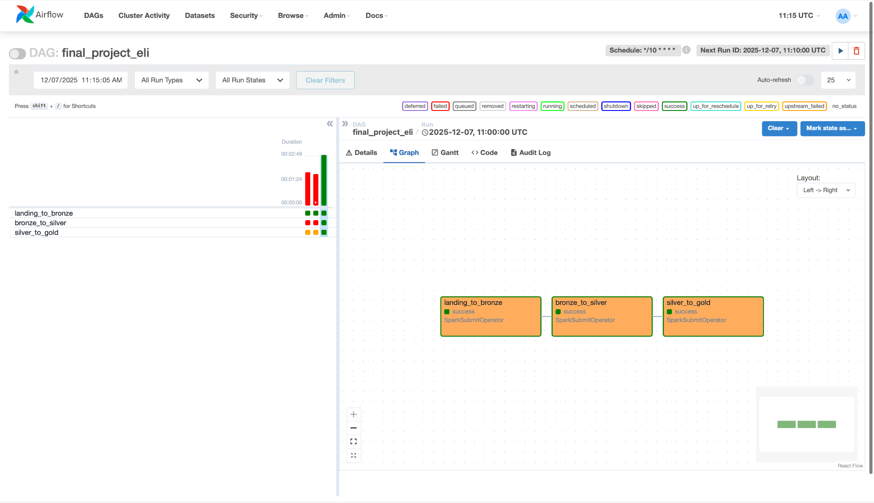
As it can be seen, all 3 stages were done successfully.

Image 2
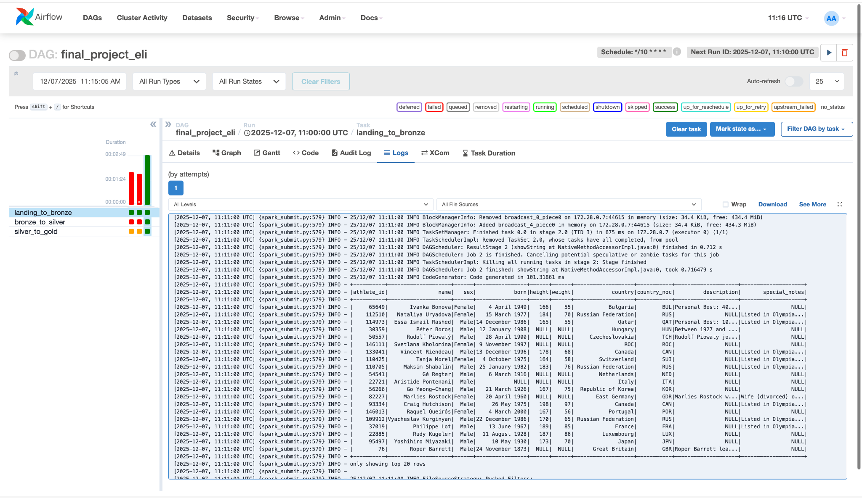

Here is data from the first stage (landing to bronze form).

Image 3
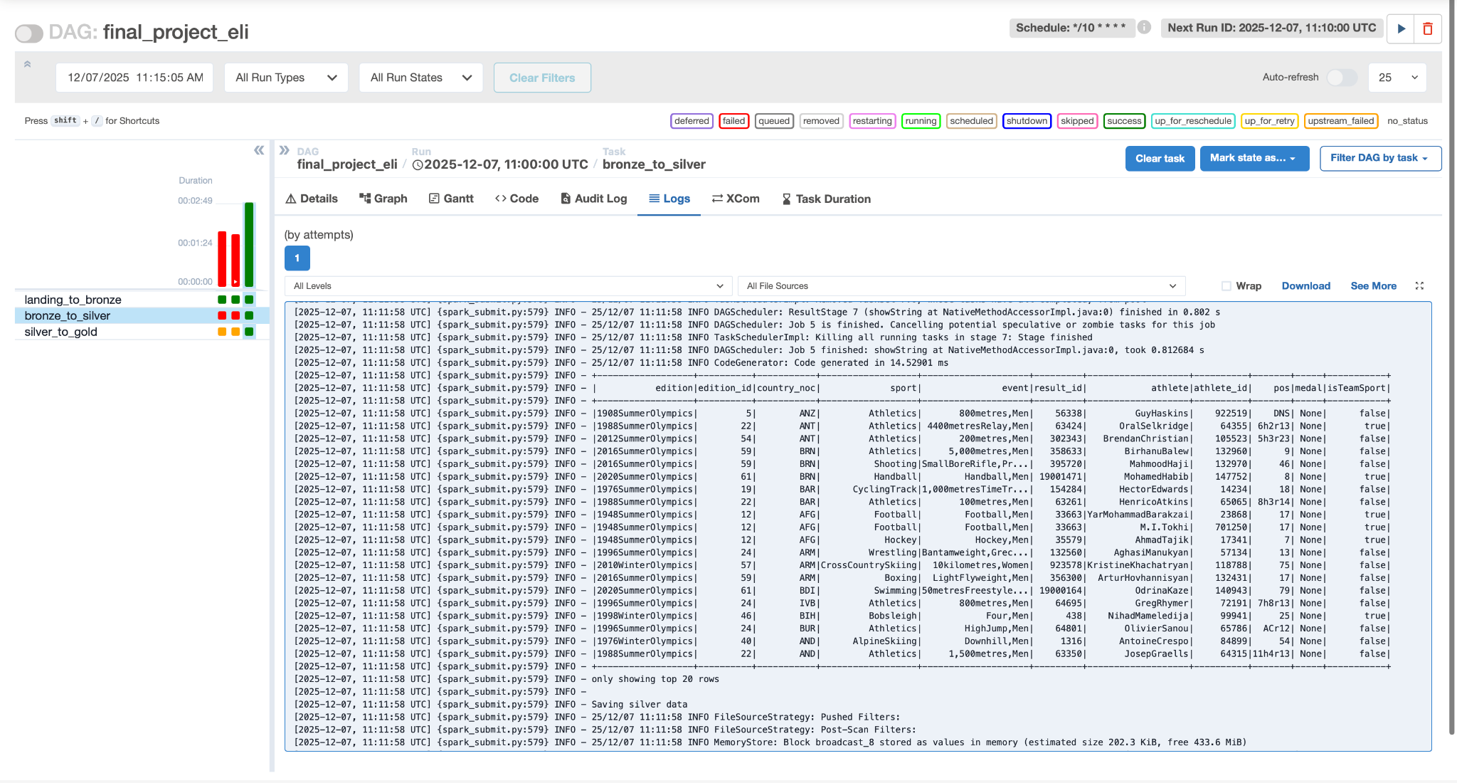
Here is data from the second stage (bronze to silver form).

Image 4
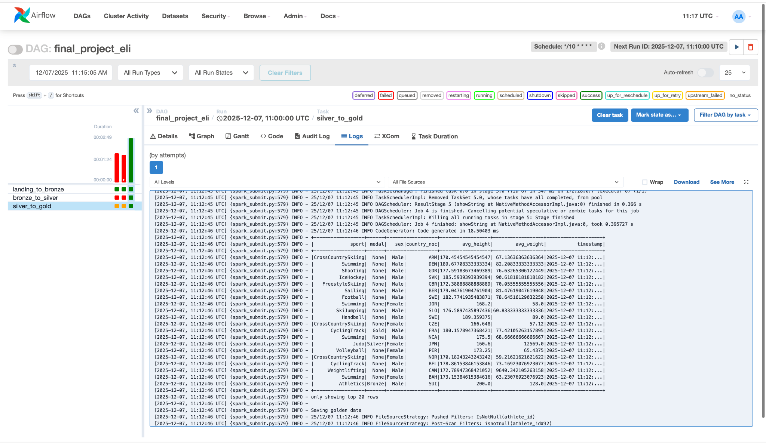
Here is aggregated data from the third stage (silver to gold form).

